Broadbridge Heath Parish Council

Supporting Documents for Parish Council Meeting
Monday 13th September 2021
7.30pm

Index

Page 3 Item 5 - Meeting Agenda and Minutes Links
Page 4 Item 8 – Clerk update
Page 5 Item 9 – Highways – Bus gate
Page 6 Item 10.1 – Village Centre final payments
Page 7-8 Item 11 - Planning Applications received in August/September 2021
Page 9 Item 12.1 - August and September Payments Lists for ratification
Page 10-12 Item 15 - Correspondence
Page 13 Item 16.1 - Memorial application

Appendix 1 – Committee Membership

Title: AGENDA AND MINUTES
Agenda Item: 5

Agenda for this meeting can be found here:
111112-Agenda_Full_Council_2021-09-13.pdf (broadbridgeheath-pc.gov.uk)
Minutes for approval are available on website using the below link:
111111-Draft_Minutes_Full_Council_2021-07-26.pdf (broadbridgeheath-pc.gov.uk)
Title: Clerk Update
Agenda Item: 6
You are asked to: Note the below information.

- Following the resignation of Cllr Roy Neilson there is currently 1 Councillor Vacancy.
The vacancy is the subject of a public notice ending on 27th September. The public notice has been shared on our website and noticeboard and details of the vacancy will be in the next BBH magazine.
- Olivia has successfully completed her ILCA course.
- Shayler’s fun fair application has been approved and insurance and safety documents have been requested.
- Migration to Office 365 last week was mostly successful. Some members experienced some technical issues. Sharepoint has now been setup for sharing of documents – this will be gradually implemented once the folder infrastructure has been reviewed.
- Staff Strategy – preparation works, with budgetary and operational considerations have been underway and is now at a final stage of preparation of a presentation with a recommendation for future staff structure. Essential tasks previously carried out by the EO are being covered internally and externally. Thank you to the members who agreed to visually inspect play areas.
- On investigation with the management company, it was confirmed that the parking spaces close to the allotment site on the WHG development are solely for use by residents/visitors as allotment holders will not be subject to maintenance fees. Parking at the site will be further considered by the allotments sub-committee.
- Hampshire Legal Services are currently working on the updated Cricket Club lease.
- Legal advice was sought in relation to the Football Club license. This will be reviewed by the clerk and members will be consulted on next steps.
- The website privacy notice was updated this month (for information only).
- All previously adopted policies have now been added to the website and a log of policies has been created to identify those requiring review/update.
- The external audit report is still awaited. There have been delays in processing these – the deadline for the publication of the notice of completion of audit is 30th September.

Title: HIGHWAYS – BUS GATE
Agenda Item: 9

You are asked to:

Note the information in the report and recommendations for discussion and decision at the meeting.

- Email received on 17th August from Mike Thomas, Highways (as previously circulated)

Thank you for your email. We do have a preferred option and we are currently reviewing resourcing this option:
* New prohibition of HGVs (except access) in one directions (West Bound) from Tesco's Roundabout to the Coop junction.
* New prohibition of HGVs (except access) in one directions (East Bound) from Newbridge Road to Sargent Way.
* Implement ANPR Bus Gate Camera to go live as close as possible as the HGV ban Order.
* Propose permanent solution for the car park (and review removing existing no entry signs)
* Live with the additional cars in Sargent Way and hope the reduction in HGVs eases the traffic concerns in the area. If this does not residents will need to request a CHS
There will be a traffic regulation order, as well as electrical connections and associated groundworks, so this will not be quick. My best estimate is next calendar year, however this will not be done by my team so I cannot commit to timescales. We will also have to get WSCC Cllr approval, however I do not see this being an issue.
The TRO process is a democratic process so there is no guarantee it will be implemented, however I do not anticipate any issues.
I am aware that this scheme may not resolve all the issues, however I believe anything further than this will require a new Community Highway Scheme proposal.
- District Cllr Potter discussed the issues with Cllr Oliver with a view to disappointment that there is still no indication of timescales, given the disruption the issues are causing.
- Cllr Oliver met remotely with Matt Davey, Director of Highways, Transport and Planning on 26th August to discuss the issues and will provide a members update.
- District Councillors met with Adam Chalmers and Adrian Smith at HDC to see what pressure they might apply to senior Highways officers to emphasise the urgency of this work. Following that a meeting was arranged between senior officers from both authorities.
- County Councillor Christian Mitchell updated on 10th September:
I've been able this afternoon to have an oral update briefing about the ANPR system (on the bus gate) and timescales. The timescales for approving a contract to it being installed to the ANPR being switched on is end of January. That however still comes with the important issues of Sargent Way and the Co-Op car park matters being resolved.
With regards to the Co-Op - they and the land owner (held in trust) and the trustees of the land are have been written to and chased. With regards to the TRO for the HGVs WSCC have agreed to fund the TRO but of course it needs to be implemented.
- Councillor Mitchell intends attending the Parish Council meeting on Monday.

Title: VILLAGE CENTRE FINAL PAYMENTS
Agenda Item: 10.1

You are asked to note the below information in preparation of the meeting.
Following consultation with the architect, Village Centre Trustees and Parish Council members, the final payment to Uprise (£16,826.74 + VAT -the one year 2.5% retention fee), and the final invoice from Richard Atkinson (£1498.02 +VAT) were paid by the parish council in June 2021.

These final payments form part of the maximum £42k that the Village Centre Trustees agreed to contribute to the project.

Title: PLANNING APPLICATIONS RECEIVED IN AUGUST AND SEPTEMBER
Agenda Item: 11

Appln | Address | Details | Committee Comments
DC/21/1557 | 24 Billingshurst Road | Removal of existing rear projection and detached shed and erection of a single storey rear extension. | No objections, provided no material objections from adjacent or adjoining properties and providing the building is not built on the boundary line or with overhanging guttering.  Submitted 25th August.
DC/21/1276 | Village Centre Recreation Ground | Creation of a vehicular access | Supported by Parish Council as applicants
DC/21/1507 | Broadbridge Heath Retail Park | Display of 1x internally illuminated totem sign and 2x internally illuminated digital signs | Objection to the proposed sign on the old bypass, shown as D48 Digital Signage, which was cited as inappropriate for this location.(The other signs look to be acceptable for their proposed locations).  Error highlighted on plans referring to Broadmead rather than Broadbridge.  Submitted 31st August.
DC/21/1718 | Rear of the property at Wickhurst Square. | Removal of Condition 1 and 6 of previously approved application DC/19/2479 | No objections provided noise output is checked when in operation and not a nuisance for the nearby residents.  Noted and informed error with on-line plans for this application also including drawings for an application in Chennells Way Horsham.  Submitted 8th September
DC/21/1394 | 31 Sargent Way | Part conversion of existing garage to additional accommodation | Comments submitted:  As in other similar applications it is regrettable that the applicant wishes to change the garage into accommodation, causing reduction in off road parking, albeit for use by a disabled person.  The front elevation change will also affect the street scene as originally designed and built.  As other similar applications have seemingly been granted, our Planning Committee reluctantly do not object, but would make the above comments in response.  Submitted 8th September.
DC/21/1640 | 25 Kilhams Close. | Erection of a single storey rear extension | No objection to the application, providing the owner of the adjoining property has no material concerns, the below comments were received:  * proposed rear extension would now be at the boundary line with the adjoining property therefore enforcing a new fixed structure as the boundary, which could give rise to potential problems in the future.  * it is unclear whether this proposed extension will deprive the adjoining property of light particularly in the first half of the day as the rear of the property faces South.  Submitted 31st August.
DC/21/1887 | 7 Adams Close | Loft conversion with new rooflights to the front and rear elevations | Comments to date (not yet submitted)  No objection but concerns on the change of street scene with the addition of Velux windows in the front (and rear) elevation.  This may look out of place based on the adjacent / surrounding properties.
DC/21/2002 | 8 Weston Avenue | Erection of a single storey rear conservatory | Comments to date (not yet submitted):  No objections, provided there are no material objections from owners of the adjacent properties.
DC/21/2052 | 59 Billingshurst Rd | Erection of a single storey rear extension.

Title: PAYMENTS LISTS FOR RATIFICATION
Agenda Item: 12.1

List of Payments made between 01/08/2021 and 11/09/2021

Date Paid | Payee Name | Reference | Amount Paid | Transaction Detail
01/08/2021 | West Sussex LGPS | OP662 | £844.04 | Month 4 Pension Remittance
01/08/2021 | HMRC | OP663 | £635.68 | Mth 4 PAYE and NI
01/08/2021 | Mr John Pilkington | OP664 |  | Month 4 Salary and Expenses
01/08/2021 | Mrs lucinda Edwards | OP665 |  | Month 4 Salary and Expenses
01/08/2021 | Mrs Olivia Buck | OP666 |  | Month 4 Salary and Expenses
01/08/2021 | Mulberry and co | OP667 | £126.00 | 1st Qtr Payroll Inv17951
01/08/2021 | Horsham District Council | OP668 | £49.60 | July 660l Bin Inv9696466
01/08/2021 | SLCC | OP669 | £36.00 | Training Inv BK202652
01/08/2021 | HR Services partnership | OP670 | £42.84 | Inv 13217 June 2021
01/08/2021 | CONNECT COMMUNICATIONS | OP671 | £11.99 | Inv 4312 Monthly VM July
01/08/2021 | BARNSFOLD NURSERIES | OP672 | £698.40 | Inv 90539 Hanging Baskets
01/08/2021 | GRASSTEX Ltd | OP673 | £1,142.40 | Inv4603 Grass Cutting
01/08/2021 | SURREY HILLS SOLICITORS | OP674 | £1,533.00 | Inv 5456 P/Office Acquisition
01/09/2021 | Mr John Pilkington | OP675 |  | M5 Salary and Expenses
01/09/2021 | Mrs lucinda Edwards | OP676 |  | M5 Salary and Expenses
01/09/2021 | Mrs Olivia Buck | OP677 |  | M5 Salary and Expenses
01/09/2021 | Mr Terry Oliver | OP678 | £320.00 | Chairman Expenses
01/09/2021 | Mulberry and co | OP679 | £210.00 | Training Inv 50262
01/09/2021 | VISION ICT | OP680 | £36.00 | Invoice 13507 - Admin fees
01/09/2021 | RIALTAS BUSINESS SOLUTIONS | OP681 | £148.80 | Alpha Annual Support 23948
01/09/2021 | Horsham District Council | OP682 | £49.60 | Refuse colln July 9738517
01/09/2021 | Horsham District Council | OP683 | £38.00 | Jet wash Ducky 9742123
01/09/2021 | CONNECT COMMUNICATIONS | OP684 | £11.99 | Voicemail service 0816
01/09/2021 | HR Services partnership | OP685 | £314.16 | HR Advice support July 13351
01/09/2021 | GRASSTEX Ltd | OP686 | £1,243.80 | Grasscutting 4679
01/09/2021 | DM Services | OP687 | £240.00 | Bench maintenance 19308
01/09/2021 | WILBAR ASSOCIATES | OP688 | £1,074.00 | Atten Survey 19221
01/09/2021 | SURREY HILLS SOLICITORS | OP689 | £750.00 | Parish Office Acq 5605
01/09/2021 | WS COMMUNITY VOLUNTEERS | OP690 | £250.00 | WS COMMUNITY VOLUNTEERS
01/09/2021 | 4 SIGHT VISION SUPPORT | OP691 | £200.00 | Grant application
01/09/2021 | West Sussex LGPS | OP692 | £890.01 | M5 Pension remittance
01/09/2021 | HMRC | OP693 | £825.34 | Mth 5 PAYE and NI

Title: CORRESPONDENCE
Agenda Item: 15

You are asked to note the below correspondence and associated recommendations:

- EMAIL FROM RESIDENT IN RELATION TO A264 DUAL CARRIAGEWAY

25th August - original email received from resident, forwarded to District and County Cllrs.
I would like to ask if there is any intention by the powers in charge of
WSDC to install traffic cameras along this stretch of road or any form of
traffic calming?
We live in the development south of the road in question and cannot accept
the anti social behaviour of some drivers using this road section. There
are cars and motorbikes using this section as a race track and invariably
in early morning or late at night. This is creating excessive noise of
which I believe exceeds the accepted noise levels and more importantly,
ruining our lives living in an area adjacent to the 'beautiful West Sussex
countryside'.
We had always accepted the build of this dual carriageway when we bought
our property but feel that enough is enough and a control must be brought
in to ensure the speed limit is observed and that noise levels are
monitored.
Certainly at this time of year most home owners have windows open for
ventilation and their health but this accentuates the speed and hence noise
levels from early morning until late night.
I look forward to your early response.

31st August – response from Cllr Mitchell, forwarded to resident:

WSCC (not HDC nor any local authority at any tier) do not have the powers to install speed cameras. In fact legislation separates out the role of the highways authority in maintaining the roads and the police in enforcing speed limits (the same as Highways' England to not enforce the speed limit on the motorway but traffic police do). Further, WSCC do not have any special ability to lobby or insist from the police installation of speed cameras. This is to separate out the powers of the public bodies.
The resident would be able to write to -
Firstly, the safety partnership: https://www.sussexsaferroads.gov.uk
Secondly, the legislation back from 2015 Government provided for Police and Crime Commissioners so that if the police were not focusing on the public's priorities then a single politician could be contacted where the police were not responsive. This replaced the old Police Panels. The details of the Commissioner to write to is: https://www.sussex-pcc.gov.uk

1st Sept – response received from resident:

Many thanks for passing on my concerns to the persons you thought would be best to deal with my concern.

I appreciate being made aware that there are other bodies that would look into my concerns but thought, foolishly, that those you saw fit to answer my points would have gone the 'extra mile' to address my concerns more sensitively rather than passing the buck!

I believe that the PCC at Broadbridge Heath do fine work within the community and even have occasions when councillors spend their own time observing speeding motorists and more. Does this not count towards protecting members of the community as I believe an accident waiting to happen on this section of the A264 will not be long in coming.

RECOMMENDATION:

- For Parish Council to write to Police and Crime Commissioners and Sussex Safer Roads Partnership outlining the identified concerns.

- EMAIL FROM FIELD PLACE ESTATE IN RELATION TO USE OF FERTILISERS (see appendix for report)

23rd August - Original email from Field Place

Please would you kindly draw to the attention of the BBH Parish Councillors our concern that it appears that allotments are being laid out between Solomon’s Seal and the Village Green on the north side of BBH. As we have mentioned earlier, we seem to be experiencing increasing nitrate and phosphate pollution of the Broomswick Stream which runs past Solomon’s Seal and the new allotments into the Ducky Pond and then under the Broadbridge Heath Road into this Estate where our works to the restored lake 4 are still in progress. Evidence of the increasing level of nutrients in the water was the infestation of Himalayan Balsam which appeared last year, for the first time since 1985, in the stream leading from the Ducky Pond. Himalayan Balsam is present next to the fields north of Solomon’s Seal. As you know, it is an invasive weed which thrives on increased nutrient levels to out-compete native species. The source of the increased nutrients is likely to be the landscaping and private gardens of Solomon’s Seal. This will be exacerbated if there is run-off of such nutrients from the new allotments.

If the Parish Council is in control of the allotments, we request that conditions of use be imposed on the allotment-holders which specify that no artificial fertilisers of any kind are used there. This should also apply to herbicides and pesticides which may both adversely affect wildlife and vegetation in the Broomswick Stream and the Ducky Pond as well as the water course flowing through our own lake system.

In addition, we request that evergreen trees are planted along the northern boundary of the allotments to absorb any excess nutrients which may flow from organic fertilisers which may be applied to the plots.

We attach a recent appeal decision regarding projected increased levels of phosphates near to wetlands which demonstrates the increasing focus on this issue. We are sure that the BBH Parish Council will wish to be at the forefront of protecting our countryside from the harm which may arise because of the use of chemical aids in the allotments.

We look forward to hearing from you.

3rd September – Follow up email from Field Place

Further to our email of 23rd August, the stream leading from the Ducky Pond and flowing into Lake 4 has now become infested with submerged blanket weed which has never happened before since we purchased the Field Place Estate in 1983. We understand that the most likely cause of this infestation is an increase in the amount of nutrients passing into the water causing an algae boom. This is almost certainly because of the use of artificial fertilisers in the gardens and patio areas of Solomon's Seal and will be exacerbated if they are used in the proposed allotments.

We are very concerned by this problem because we understand that the only sure way of temporarily removing the blanket weed is by the use of chemicals which have not been used here since 1985. We also understand that removing the weed by hand only increases the infestation later and elsewhere because it releases spores into the water course so we are unable to use any of our usual methods of dealing with noxious plants.
Please, therefore, draw this problem to the attention of your Parish Councillors when they are considering the allotments east of the recreation ground and repeat our request that any licence to individuals to use an allotment should be conditional upon the avoidance by them of the use of all artificial fertilisers and pesticides. Otherwise, the Broomswick Stream is likely to become even more polluted with serious consequences for the lake system on the Field Place Estate.

9th September – Holding response to Field Place

Thank you for your email dated 3rd September, which has been noted and the correspondence added to the next Parish Council Meeting Agenda. We will respond further after the meeting next week. At present the Allotment Site at Weston Avenue is still managed and owned by the Developer Belway, but work continues by the Parish Council in preparation for the future acquisition.

9th September – Reply from Field Place

Many thanks. Please would you pass our emails to the person with whom you are dealing at Bellway.

RECOMMENDATIONS:

- To refer this item to the Allotments Sub-Committee for consideration when agreeing the rules for allotment holders.
- To forward details on to contact at Bellway per request.

Title: BENCH MEMORIAL APPLICATION
Agenda Item: 15

A completed application has been received to place a memorial bench at Charrington Way recreation ground (location per member suggestions). Please see associated application (not in report for confidentiality).

Within the application the resident has requested possibility of alternative bench design as below:

https://uk.glasdon.com/larbreck-tm-hardwood-seat

Members are asked to

- Consider approval of the above bench type for this application, noting the adopted policy states:
“The applicant is responsible for maintenance of the bench, and associated costs”.
- Confirm approval of the location (approx location identified as image below – between 2 green markers)

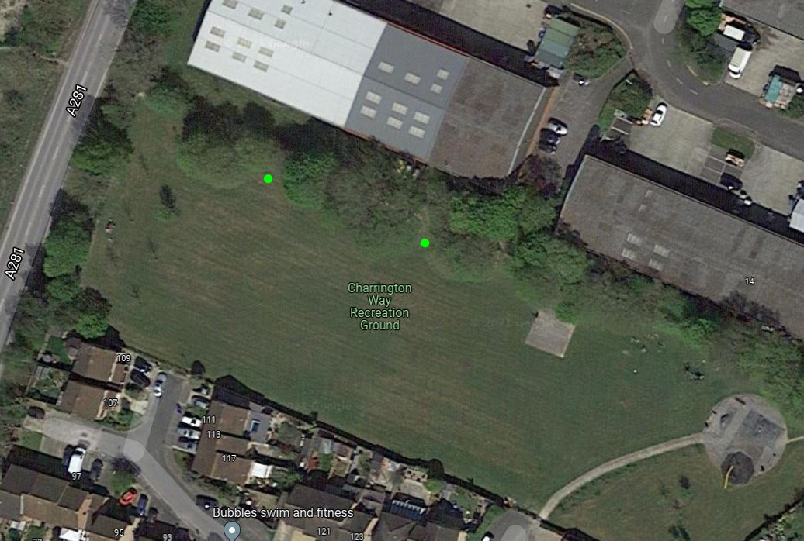

- Confirm approval of the wording of the plaque
- Approve recommendation to seek quotes for the installation of above bench in location agreed and put together a cost proposal for the applicant.

APPPENDIX 1: Committee Membership September 2021
COMMITTEES
- Recreation Committee
Cllr Knight (Chair)
Cllr Edwards
Cllr Oliver
Cllr Coker
Cllr Milbank
Cllr Hayles
VACANCY

- Finance and Establishment Committee
Cllr Trangmar (Chair)
Cllr Clark
Cllr Edwards
Cllr Oliver
Cllr Knight
Cllr Milbank

- Personnel Committee
Cllr Knight (Chair)
Cllr Oliver
Cllr Edwards
Cllr Trangmar
Cllr Clark

- Planning Committee
Cllr Clark (Chair)
Cllr Milbank
Cllr Coker
Cllr Hayles
VACANCY

- Allotments Sub Committee
Cllr Milbank (Chair)
Cllr Hayles
Cllr Clark
Cllr Knight
Cllr Oliver

WORKING PARTIES
- Parish Office WP
Cllr Knight
Cllr Oliver
Cllr Edwards
Cllr Trangmar
Clerk Lucinda Edwards

