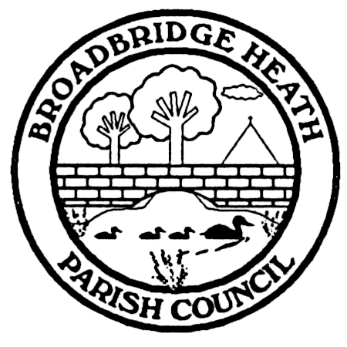
Broadbridge Heath Parish Council
Recreation and Environment Committee
Adopted by council: 5th June2023
TERMS OF REFERENCE
This committee, comprising of up to seven councillors will meet as deemed appropriate by the Chair of the Committee or by the council.
The Recreation Committee has delegated authority to authorise expenditure of up to £2,500 on recreational and environmental activity on Parish Council owned land (eg play equipment, maintenance of open spaces, trees, gates/fences, ponds etc.).
The Recreation Committee is subject to the governance of Standing Orders and must carry out its business accordingly.
MAIN FUNCTION
- The efficient and effective management of all Parish Council owned and managed open space/recreational/streetscene matters
- To seek high standards of health and safety (through inspections, repair and maintenance) in connection with Parish Council land and any equipment or buildings on it
- To work with the community, sports associations, local authority and contractors in relation to open spaces and facilities set aside for leisure, recreation and amenity
- To approve work required (up to £2,500) with regard to open spaces and review quotes >£2,500 making a recommendation to the Parish Council for approval
- To consider documents relating to open space/recreation/trees to include lease arrangements and make recommendations to Parish Council
OTHER
- Put forward a budget proposal for related expenditure
- To represent the Parish Council at relevant meetings
- To explore sources of fund raising
The Terms of Reference for this committee will be considered annually.

