Dear Residents,
There have been some comments and queries about the recent winter management work carried out at Top Common, so I asked local volunteer, David Bridges, to set out the background to this area and to explain why it is necessary to carry out work there each winter. Here is what he had to say.
‘Back in 2016 I was asked by the Parish Council to coordinate some work at Top Common to create a nature area and a pleasant place for local people to visit.
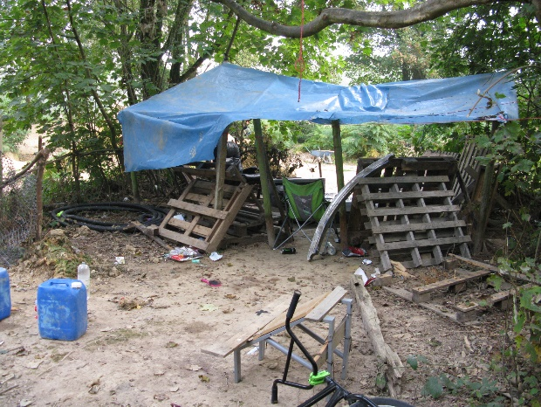
For some years, the area had been used for off-road biking and as a ‘bike jump’, but it had also become a haunt of drug users and as a place where rubbish was fly-tipped.
The first task was to clear the rubbish and to remove any unsafe trees. Many trees had been vandalised and were in a poor condition.

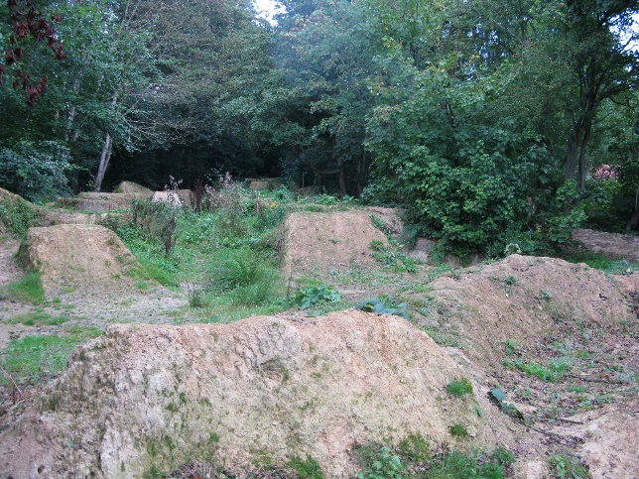
The central part of the site consisted of a series of bare earth mounds and pits shaped from soil brought on site by local developers. The remainder of the area was heavily overgrown and very shady. The dense shade was preventing any wildflowers from emerging and meant wildlife on the site was very limited. A baseline survey revealed that the area was largely devoid of any bees, butterflies or other pollinating insects.

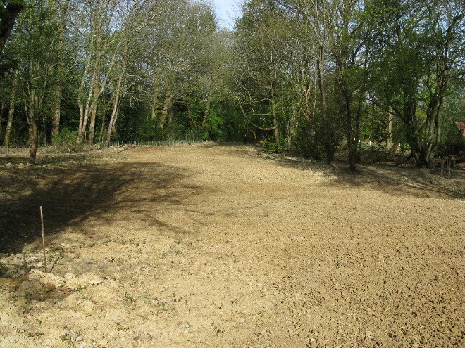
Once the area was cleared of rubbish by a team of volunteers (we removed about 1 ton of rubbish), we levelled the mounded areas and filled in some deep pits. The area was then power-harrowed to create a tilth into which UK-sourced native wildflower seed could be sown. The mix we used included many wild perennial species such as Red Campion, Knapweed and Cowslips plus some annual wildflowers such as Corn Marigold and Ox-eye Daisy. I hand sowed 3 kg of wildflower seed.

The decision to create a wildflower meadow in the central area was taken for several reasons. Over 97% of the UK’s wildflower meadows have been lost so this was a good opportunity to put back a small area of this type of habitat. A wildflower meadow would, we thought, support a wide range of insects which, in turn, would be a valuable source of food for birds, bats and other creatures. The seed heads of the wildflowers would provide further food for birds during the winter months.
We also planted over 300 hedge plants along the back of the site, created a small hazel copse at the northern end, put up nestboxes and laid out over 350 metres of woodchip paths. I have also put in plug plants and sown seeds of range of wildflowers that can cope with the shadier areas, including the Foxgloves that are much admired and commented on by visitors to Top Common each year.
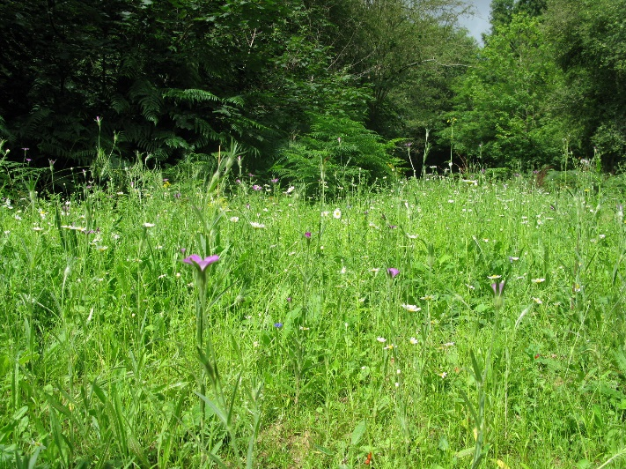

Overall, the results, even in the first summer, were amazing with a profusion of wildflowers and grasses emerging.

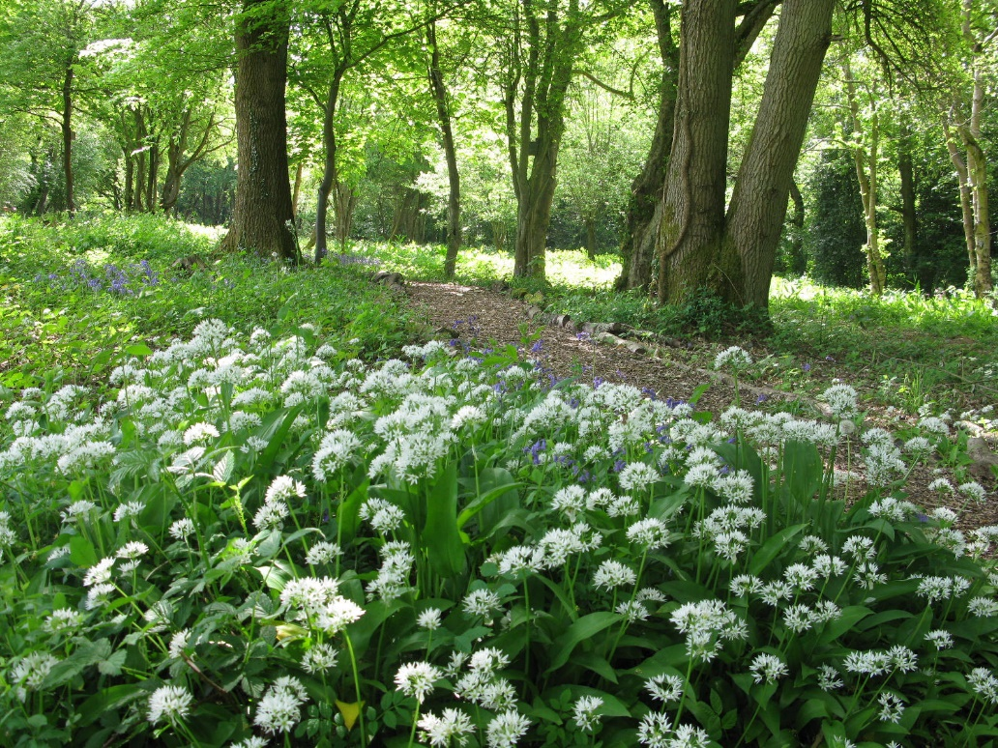

Also, once the area was cleared and some sunlight let in, we found that there were snowdrops, bluebells, wild garlic and some very attractive ferns that had all been lying dormant just waiting to emerge.

Since this work was carried out, the range and number of species seen on Top Common has increased every year. Marsh Tit (a red list species bird) visits the site to feed and has bred there, at least 19 species of butterfly, including the rare Brown Hairstreak, have been recorded (there were no butterflies in 2016) and in mid-summer the space is alive with countless bees, hoverflies, dragonflies, grasshoppers and other insects.
Sadly, we have suffered from some vandalism. Some of the nestboxes were destroyed in the first year and quite a lot of the hedging plants have been damaged or uprooted. We are gradually replacing these as time and finances permit.
It has also been an ongoing challenge to keep the footpaths clear of bramble, nettles and the occasional fallen tree. A small team of dedicated local volunteers has undertaken this work.
In order to maintain the meadow habitat and also to ensure that the Bluebells, Wild Garlic and other wildflowers re-emerge each year, it is important to carry out some pretty intensive winter management every year to remove dead vegetation and let in some natural light. Otherwise, the area would quickly become overgrown, very dark and inaccessible.
We do the work as late as possible so that birds have access to any seed heads and berries through the winter months, and of course, we always finish before the bird nesting season gets underway in the spring.
Each winter we flail the central area and any areas where bramble is shading out the ground flora. I remove bramble from around the Hazel copse by hand. All the material we cut is removed and stacked. This is because the cut material would otherwise enrich the soil as it rots down and would encourage the growth of grasses and other rank vegetation over the wildflowers we are trying to encourage. The stacks of cut material provide a great refuge for Grass Snakes, amphibians and a huge range of other creatures.
This management has been carried out every winter since I have been involved at Top Common and, so far, the results have been very good. Each year we record more wildlife and different species of wildflower at Top Common.
The area does look very bare after cutting and I do worry about how the site will respond. Fortunately, nature is extremely resilient and I think the results each spring and summer speak for themselves.
As a volunteer, I have limited time to put into the ongoing management of Top Common and I would very much welcome more people coming forward to join our small group of active volunteers and to participate in how the site is managed going forward and to assist with the work.
Once the Covid restrictions have eased I hope to arrange a few short guided walks and talks on site to highlight some of the amazing wildlife that can be found at Top Common.
If you would like to join our volunteers and get involved please contact the Parish Clerk’.

Please like and follow our Facebook page and website for further updates.
Regards,
Lucinda
Clerk, Broadbridge Heath Parish Council

